TASK 2 – Choose the Data Representation
Aim: To select suitable Java data types and arrays to represent the floors, parking slots, vehicle details, entry time, parking duration, and parking fee.
  - Data Types Used
Data | Java data type | Reason
Floor number | int | Stores the floor index.
Slot number | int | Stores the slot index.
Vehicle registration number | String | Stores letters and numbers.
Vehicle type | String or enum | Identifies the vehicle category.
Entry time | LocalDateTime | Stores the date and time of entry.
Exit time | LocalDateTime | Stores the date and time of exit.
Duration | long | Stores parking duration in minutes.
Parking fee | double | Stores the calculated fee, including decimal values.
Ticket number | long | Stores a unique numeric ticket number.
Slot availability | boolean | Indicates whether a slot is free or occupied.

  - Representation of Floors and Slots

I would use a jagged two-dimensional array because each floor may contain a different number of slots.

String[][] slots = {
new String[3],
new String[5],
new String[4]
};

Here:
- slots[0] contains 3 slots.
- slots[1] contains 5 slots.
- slots[2] contains 4 slots.
- A null value indicates that a slot is free.
- A non-null value stores the registration number of the parked vehicle.
This representation is suitable because different floors can have different numbers of parking slots.
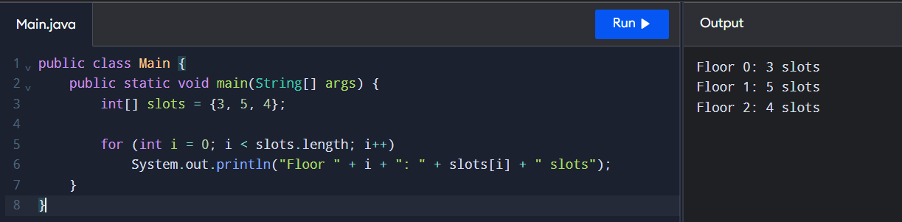
  - Type Conversion and Casting
Type conversion is required when calculating the parking duration and fee.
For example, if a vehicle is parked for 90 minutes, the duration is converted into billable hours. If every started hour is charged in full, 90 minutes must be charged as 2 hours.
int minutes = 90;
int hours = (minutes + 59) / 60;
System.out.println(hours);
Output:
2
The formula (minutes + 59) / 60 performs ceiling division for non-negative minutes using integer arithmetic.
  - Risk of Integer Division
Consider this incorrect calculation:
int minutes = 90;
int hours = minutes / 60;
System.out.println(hours);
Output:
1
This is incorrect because integer division discards the fractional part. The correct billable duration is 2 hours.
We can avoid this error by using:
int hours = (minutes + 59) / 60;
For a fee of ₹30 per hour, the correct fee is:
\[ 2 \times 30 = ₹60 \]
  - Reading Input
The Scanner class can be used to read the vehicle registration number and other details from the user.
import java.util.Scanner;
class ParkingInput {
public static void main(String[] args) {
Scanner sc = new Scanner(System.in);
System.out.print("Enter vehicle number: ");
String regNo = sc.nextLine();
System.out.print("Enter parking duration in minutes: ");
int minutes = sc.nextInt();
System.out.println("Vehicle: " + regNo);
System.out.println("Duration: " + minutes + " minutes");
sc.close();
}
}
Sample Input:
TN01AB1111
90
Sample Output:
Vehicle: TN01AB1111
Duration: 90 minutes

  - Alternative Concept and Complexity Analysis
Instead of a jagged array, the system could use a one-dimensional array or an ArrayList<String[]>.

Comparison
Representation | Advantages | Limitations
Jagged array | Each floor can have a different number of slots. | Requires nested loops to search all slots.
One-dimensional array | Simple storage and traversal when all slots are mapped to one index. | Needs index calculations and extra mapping for unequal floor sizes.
ArrayList<String[]> | Flexible collection of floor arrays. | Slightly more collection overhead.
For a one-dimensional array with equal slots per floor, the index can be calculated as:
index = floor * slotsPerFloor + slot
When floors have different numbers of slots, the simple formula does not work directly. Prefix offsets or a mapping table are required.

Time and Space Complexity
Let \(F\) be the number of floors and \(S\) the maximum number of slots per floor.
- Searching for a slot: Worst-case time is \(O(FS)\) for a jagged array.
- One-dimensional array: Searching all slots takes \(O(N)\), where \(N\) is the total number of slots.
- Space complexity: Both representations require \(O(N)\) space for \(N\) total slots.
- ArrayList: Also requires \(O(N)\) space, with additional collection-management overhead.

Result
Thus, suitable Java data types and a jagged two-dimensional array are selected to represent the Campus Smart-Parking System. Correct integer arithmetic prevents billing errors, and the design supports floors with different numbers of parking slots.

